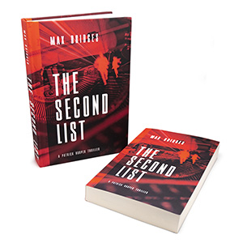

Editorial Praise
‘The Second List is as good as any of my favorite authors, and that includes Daniel Silva, Louise Penny, and Michael Connelly. I nearly did not put it down from the start and only did so for brief time periods. I rate his well-crafted book as a 5/5.’ – Don, Men Reading Books

‘The Second List is an interesting, well-written and well-paced thriller that engages from the first paragraph. The reader is immediately invested in the stories of all the main characters and will be eager to read on to learn more about their fates.’ - Disha Mistry, Cenveo Publisher Services

Reader’s Praise
‘The Second List has to be one of the best reads I’ve had all year, and to realize this novel is [the author’s] first is simple remarkable.’ – Wendyl Leslie, Amazon

‘This is a well written thriller that hits all the right marks. A story that throws you into the action, has international locales and flavor, thrilling twists and sequences.’ – Mel Dashing, Amazon

‘This book has all the right elements for great thriller movie! From start to finish there's not a single dull moment I must say. Adventurous, thrilling and racy.’ - Arav, Amazon

maxbridgesauthor.com – hello@maxbridgesauthor.com
© 2021, Max Bridges

