By Max Bridges

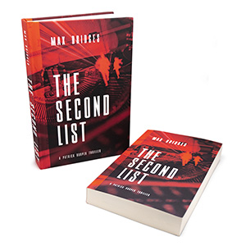

Patrick Rooper, an investigative journalist and ex-Navy SEAL, is looking forward to his upcoming wedding when a rich socialite walks into his office and offers a lucrative assignment. To retrieve a document from the Swiss Alps seems easy enough for someone with Patrick’s accolades, but unbeknownst to him, the undertaking poses an existential threat to someone powerful—someone desperate to stop him at any cost.
The socialite’s granddaughter, Susan, gets pulled into the unfolding events and narrowly escapes a deadly assassin. When chance unites her with Patrick, the duo must solve the mystery around the document if they want to survive. But with every revelation, the seemingly impossible effort to save their lives draws them even deeper into danger. After a chase halfway around the world, the pair makes a fateful discovery.

maxbridgesauthor.com – hello@maxbridgesauthor.com
© 2021, Max Bridges

