Bibliographic
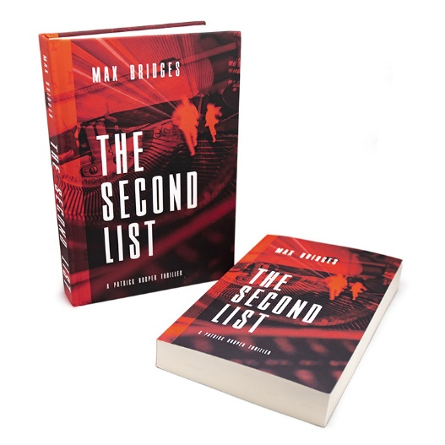

ISBN: eBook 978-1-7368040-0-1
Paperback 978-1-7368040-1-8
Hardcover 978-1-7368040-2-5

Title: The Second List
Author: Max Bridges
Publisher: Jeunive Publishing, LLC

Format: eBook, Paperback, Hardcover
Price: eBook $9.95
Paperback $17.95
Hardcover $24.95

Publication Date: 10/12/2021

BISAC Audience: 01- General/Trade
BISAC Subject: FIC030000

maxbridgesauthor.com – hello@maxbridgesauthor.com
© 2021, Max Bridges

