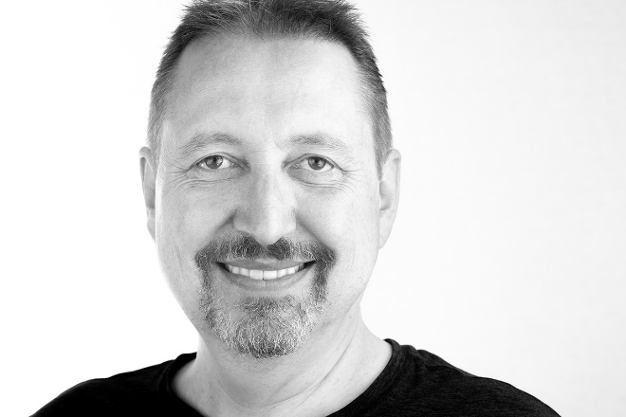

Max Bridges was born and raised in Switzerland. After successful studies at the renowned Architectural Association School of Architecture, London, and Columbia University, New York, opportunity brought him to Southern California, where he now lives with his wife, two daughters and a dog.
As in any discipline of his creative work, the concept behind is not only present but always paramount—the final product merely a conclusion of its developed narrative. The push into the media of typed words seems nothing more than a logical extension to his already expansive portfolio spanning architecture, design, and photography.

maxbridgesauthor.com – hello@maxbridgesauthor.com
© 2021, Max Bridges

